**VI EDITOR ASSIGNMENT**

1. Invoke the vi editor with a filename (which is to be created)

**Ans: vi filename For example: vi myfile1.txt**

2. Type a few lines(at least 10) in the editor. Let one or more lines contain the words given below.

delhi mumbai chennai Mumbai

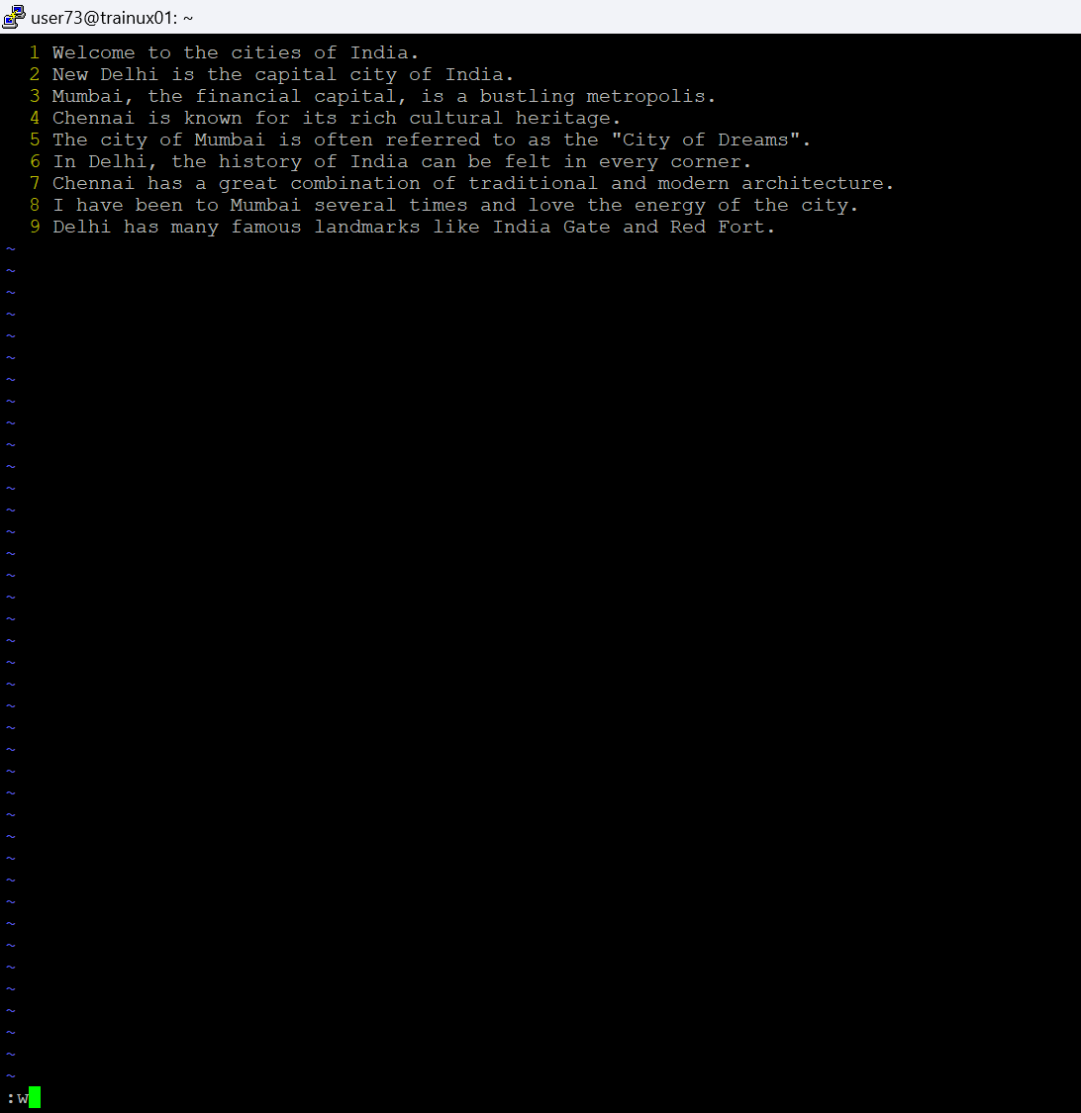

1. Save the file without exiting the editor

**Ans: To save the file “w” is used**



1. Navigate quickly to the beginning & end of the file

**Ans:**

* **To move to the beginning of the file. Press “Esc” and in command mode type “gg”.**
* **To move to the end of the file. Press “Esc” and in command mode type “G”.**

1. Delete first two lines & copy it after the last line.

**Ans: Delete the first two lines:**

* **Type :1,2d and press Enter.**
* **This command deletes lines 1 to 2 (the first two lines).**

**Copy the deleted lines (also known as "yank" in vi) to the end of the file:**

* **Type :.$ and press Enter to move to the last line.**
* **Type “O” (uppercase) to open a new line after the last line.**
* **Then, press “p” to paste the lines you just deleted at the end of the file.**

1. Now Copy the last two lines & paste them before the first line.

**Ans:**

* **:$-1,y: Copies the last two lines of the file.**
* **gg: Moves the cursor to the first line of the file.**
* **P: Pastes the yanked lines before the first line of the file**.

1. Combine last two lines of the file in a single line.

**Ans:**

* **G: Moves the cursor to the last line.**
* **k: Moves the cursor up one line.**
* **J: Joins the current line with the next line, merging them into a single line.**

1. How will you insert a line before the first line? (Hint : Find such an option in the tutorial document)

**Ans:**

* + **O: Insert a new line above the current line.**
  + **o: Insert a new line below the current line.**

1. How will you paste a yanked buffer before the current line?

**Ans:**

* + **yy: Yank (copy) a single line.**
  + **P: Paste the yanked content before the current line.**
  + **p: Paste the yanked content after the current line.**

1. Search the document for a string “delhi”

**Ans:**

**To search for the string "delhi", type /delhi and then press Enter.**

* **The / initiates a search in forward direction (from the current cursor position to the end of the document).**
* **The text following the / (in this case, "delhi") is the string you want to search for.**

1. Replace a single occurrence of “delhi” with “Mumbai”

**Ans: :s/delhi/Mumbai/**

1. Replace all occurrences of “delhi” on a particular line with “Mumbai” using one command

**Ans: :s/delhi/Mumbai/g**

1. Replace “delhi” with “mumbai” for the entire document using one command.

**Ans: :%s/delhi/mumbai/g**

1. Replace all occurrences of “delhi” with “mumbai” for part of a document (e.g. line number 13 to 37).

**Ans: :13,37s/delhi/mumbai/g**

1. Undo the above command

**Ans: Press ESC and Press U**

1. Replace only the first occurrence of “delhi” with “mumbai” in each line, for part of a document (e.g. line number 13 to 37).

**Ans: :13,37s/delhi/mumbai/**

1. Undo the above comment. Redo it. Undo it again.

**Ans:**

* **u: Undo the most recent change.**
* **Ctrl + r: Redo the most recent undone change.**

1. Replace all occurrences of “delhi” with “mumbai” for complete file interactively.

**Ans: :%s/delhi/mumbai/gc**

1. Search for a word backwards. Loop through all matches.

**Ans: ?delhi**

1. Search for a word forwards. Loop through all matches

**Ans: /delhi**

1. Join two lines together.

**Ans: to join two lines press “J”**

1. Enable line numbering and then disable it

**Ans: :set number**

1. Make the search case insensitive

**Ans: :set ignorecase**

1. Delete 4 lines (and then paste them somewhere else)

**Ans: 4dd**

1. What is the command to delete part of the line starting from the current cursor position?

**Ans: d$**

1. What is the command to delete the current word

**Ans: dw**